'''Q.1) Write a Python function to check whether a string is a pangram or not.
Note : Pangrams are words or sentences containing every letter of the alphabet at least
once.
For example : "The quick brown fox jumps over the lazy dog" '''

def pangram(s):
alphabet = set('abcdefghijklmnopqrstuvwxyz')
unique_letters = set(s.lower())
return alphabet.issubset(unique_letters)

s = "The quick brown fox jumps over the lazy dog"
if pangram(s):
print("It's a pangram")
else:
print("Not a pangram")

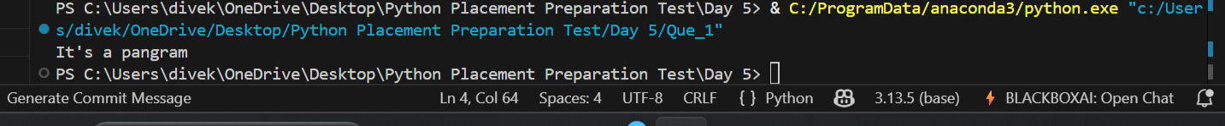

'''Q.2) Write a Python program to calculate the sum of the digits in an integer. '''

n=123
s=0
while(n>0):
s=s+n%10
n=n//10

print(s)



'''
Q.3) Write a Python program to sort three integers without using conditional statements and
loops. [ u can use built in functions for this ]
'''

a = int(input("Enter first number: "))
b = int(input("Enter second number: "))
c = int(input("Enter third number: "))

sorted_nums = sorted([a, b, c])

print(sorted_nums)

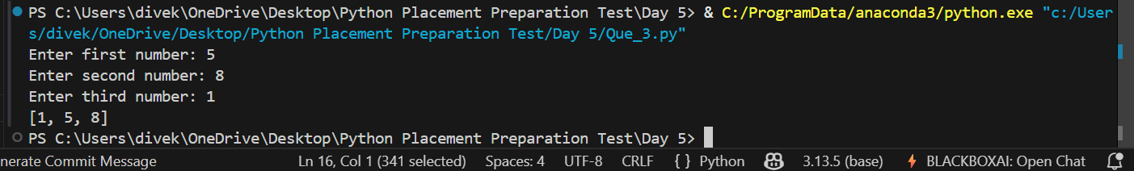

'''Q.4) Write a Python function to check whether a number is perfect or not.
According to Wikipedia : In number theory, a perfect number is a positive integer that is
equal to the sum of its proper positive divisors, that is, the sum of its positive divisors
excluding the number itself (also known as its aliquot sum). Equivalently, a perfect
number is a number that is half the sum of all of its positive divisors (including itself).
Example : The first perfect number is 6, because 1, 2, and 3 are its proper positive
divisors, and 1 + 2 + 3 = 6. Equivalently, the number 6 is equal to half the sum of all its
positive divisors: ( 1 + 2 + 3 + 6 ) / 2 = 6. The next perfect number is 28 = 1 + 2 + 4 + 7 +
14. This is followed by the perfect numbers 496 and 8128.'''
for i in range(1,10000):
n=0
for j in range(1,i//2+1):
if i%j==0:
n=n+j
if i==n:
print(i)
